# What is an AI Agent?.

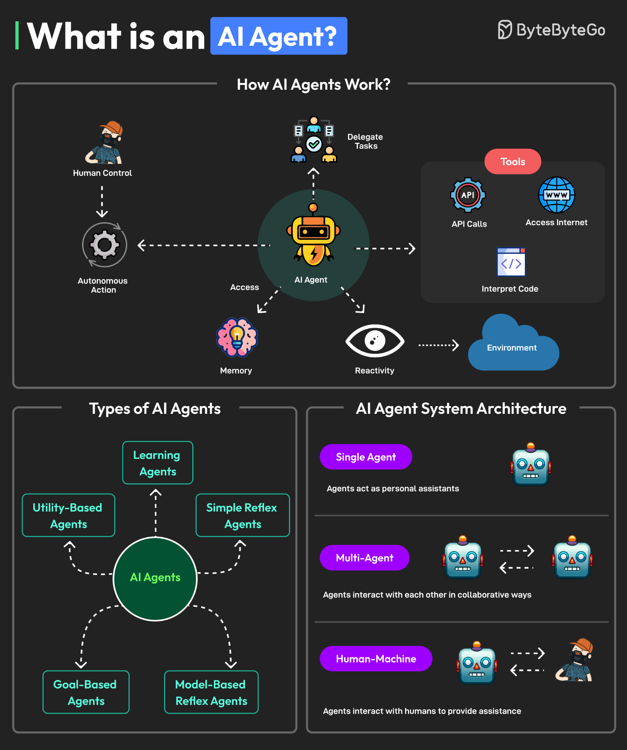

An AI agent is an autonomous software system that perceives its environment, makes decisions, and takes actions to achieve a high-level goal with minimal human oversight. Unlike a simple chatbot that responds to a prompt, an agent can perform complex, multi-step tasks, reason, plan, and learn from experience to improve its performance over time.

* Perceives and acts: An AI agent uses its environment (which can be digital, physical, or a mix) to sense information and then acts on that information to change its surroundings.
* Goal-oriented: It is programmed with a goal, and it autonomously determines the steps needed to achieve it.
* Autonomous and intelligent: It can operate independently, making its own decisions about how to accomplish the task, a capability enabled by powerful models like Large Language Models (LLMs).
* Multi-modal capabilities: Modern agents can often process and understand information from various sources simultaneously, such as text, voice, video, and code.
* Learns and adapts: Agents can improve over time through a process of trial and error, refining their decision-making based on feedback to become more efficient at reaching their goals.
* Executes complex tasks: It can perform a series of actions across different applications and platforms to complete a task that is too complex for a traditional, pre-programmed script.

### **What is Memory for AI Agent**

**Memory** in an AI Agent is the component that allows the agent to **retain, recall, and use information** from past interactions or experiences to make better decisions in the future.  
 It gives the agent the ability to maintain **continuity** across conversations or tasks, rather than treating each interaction as a separate, independent event.  
 In essence, memory allows the agent to **“learn” from the past and adapt its behavior** over time.

#### **Importance of Memory in AI Agents**

Without memory, an AI system would start fresh in every new interaction, forgetting everything it learned previously.  
 By incorporating memory, AI Agents can:

* **Understand context** — continue a conversation or task based on earlier exchanges.
* **Adapt behavior** — modify responses according to user preferences or feedback.
* **Improve performance** — use past outcomes to make better decisions in future scenarios.
* **Handle complex workflows** — keep track of intermediate steps, decisions, and outcomes across long sequences of tasks.

Example:  
 A personal assistant AI that remembers your meeting schedule, preferred restaurants, or last queries will give more relevant and personalized answers than one that has no memory at all.

#### **Types of Memory in AI Agents**

AI memory can be divided into several functional categories — inspired partly by how human memory works:

1. **Short-Term Memory (Contextual Memory):**
   * Holds temporary information related to the current session or task.
   * Example: Remembering the topic of the current conversation to respond coherently.
   * Usually stored in session context or local variables.
   * In systems like LangChain or LlamaIndex, this is managed through *conversation buffers* or *context windows*.
2. **Long-Term Memory (Persistent Memory):**
   * Retains information across sessions or over time.
   * Example: Remembering a user’s name, goals, or preferences even after the program restarts.
   * Often implemented using databases, vector stores (like FAISS or Chroma), or file storage.
   * Enables agents to "recall" information months later, improving personalization.
3. **Episodic Memory:**
   * Stores detailed records of specific experiences or actions — essentially “episodes” of interaction.
   * Example: Remembering that the agent previously searched a dataset and what results it found.
   * Helps in reasoning about cause and effect, debugging, and experience-based decision making.
4. **Semantic Memory:**
   * Contains general knowledge and facts the agent has learned — similar to human understanding of the world.
   * Example: Knowing that Paris is the capital of France, or that YOLO is a computer vision model.
   * This is often built into the agent through pre-training (like in large language models) or fine-tuning.

**Technical Implementations of Memory**

Modern AI frameworks such as **LangChain**, **LlamaIndex**, and **OpenAI Agents** include built-in memory systems that allow:

* Storing conversation history in **buffers** or **databases**.
* Retrieving relevant past information through **vector embeddings** and **semantic search**.
* Integrating with **external storage** like Pinecone, Redis, or ChromaDB for scalable long-term memory.

These systems typically represent text as vectors (embeddings) and store them in a searchable database. When a new query arrives, the agent retrieves relevant past contexts by comparing similarity between the current input and stored memories.

### **What are its Tools**

AI Agents use **tools** to interact with the real world or external systems.  
 These tools extend the agent’s capabilities beyond language understanding.

**Examples of tools:**

* **APIs:** For retrieving real-time data (e.g., weather, stock prices).
* **Databases:** To fetch or store structured data.
* **Search tools:** For looking up information on the web.
* **Code interpreters:** To execute Python or other code dynamically.
* **External software tools:** For automation (e.g., email sending, spreadsheet updates).

**In frameworks like LangChain:** Agents use “tools” as callable functions that help them perform complex reasoning and multi-step workflows.

### **What is Agentic AI**

**Agentic AI** represents the next stage in the evolution of artificial intelligence — moving beyond passive, prompt-based models to systems that can **act independently**, **make decisions**, and **carry out complex tasks** with minimal human supervision.  
 While traditional AI models (like chatbots or LLMs) mainly *respond* to input, Agentic AI systems can *take initiative* to achieve specific goals.

In other words, Agentic AI gives artificial intelligence **agency** — the capacity to **decide, plan, and act** to fulfill objectives.

Difference Between Traditional AI and Agentic AI

| Feature | Traditional AI (LLM-based) | Agentic AI |
| --- | --- | --- |
| Nature | Reactive — responds to user prompts | Proactive — takes initiative and acts autonomously |
| Scope | Limited to single-turn interactions | Multi-step reasoning and task completion |
| Memory | Short-term context only | Long-term, contextual, and episodic memory |
| Tool Use | No access to external systems | Integrates APIs, databases, or custom tools |
| Adaptability | Static responses | Learns and adapts from feedback and outcomes |
| Example | Chatbot answering questions | AI assistant that plans, searches, executes, and reports results |

**Core Components of Agentic AI**

1. **Autonomy:** Agentic AI systems can perform tasks without explicit human instruction at every step.  
    They can decide *what to do next* based on prior results and their objectives.
2. **Goal-Oriented Reasoning:** Agentic AIs don’t just follow rules — they reason about goals, choose the best strategy, and modify their plan dynamically.  
    They use **chain-of-thought reasoning**, **planning algorithms**, and **feedback loops** to stay aligned with the target objective.
3. **Planning and Execution Engine:** The system can break down high-level goals into smaller tasks and execute them in sequence or parallel.  
    Example: “Generate a market analysis report” becomes sub-tasks like fetching data, cleaning data, running analysis, and preparing visuals.
4. **Memory System:** Agentic AIs integrate **short-term**, **long-term**, and **episodic memory**, allowing them to remember previous states, recall past interactions, and learn continuously.  
    This continuity makes them context-aware and capable of long-term collaboration with users.
5. **Tool and API Integration:** These systems can call **external tools**, **APIs**, and **software applications** to take real-world actions — like sending an email, running a Python script, or fetching data from a cloud database.  
    This ability bridges the gap between *language understanding* and *real-world action*.
6. **Feedback and Learning Loop:** Agentic AIs continuously evaluate their own performance. They can use user feedback or self-reflection to refine their strategies, becoming more accurate and efficient over time.

#### **Example Scenario:**

Let’s consider an example where a company uses an **Agentic AI** for business automation.

**Goal:** “Prepare and send a weekly performance summary to the management team.”

**Steps the Agentic AI would perform:**

1. **Retrieve Data:** Access internal databases or APIs to collect the latest performance metrics.
2. **Analyze:** Use Python tools or ML models to calculate growth rates, trends, and key insights.
3. **Summarize:** Generate a natural language report highlighting important outcomes.
4. **Visualize:** Create data charts and attach them to the report.
5. **Communicate:** Email or upload the report automatically to the management portal.
6. **Learn:** Record feedback (e.g., if corrections were made) to improve future summaries.

This system doesn’t just respond — it plans, acts, and learns continuously.

**Applications of Agentic AI**

* **Business Automation:** Automating workflows like report generation, scheduling, and document management.
* **Software Development:** Auto-debugging, testing, and code optimization using LLM agents.
* **Education:** Personalized tutoring systems that adapt to a student’s learning pace.
* **Customer Support:** Context-aware assistants that can retrieve data, resolve issues, and follow up automatically.
* **Scientific Research:** Agents that search for papers, extract insights, and draft literature summaries.
* **Healthcare:** Intelligent agents that monitor patient data and alert doctors to anomalies.

**Key Technologies Behind Agentic AI**

* **Large Language Models (LLMs):** The foundation for natural language reasoning and understanding.
* **Memory Systems:** Using vector databases (like FAISS, Pinecone, Chroma) to store and recall context.
* **Tool APIs:** Connecting the AI with web services, applications, or programming environments.
* **Frameworks:** LangChain, AutoGPT, CrewAI, BabyAGI, and OpenAI’s new Agent framework.
* **Planning Algorithms:** Enabling multi-step reasoning and adaptive task management.